Hello WHKF Purple Lady workshoppers,
For the new members to this group, hello. It's called the "Purple Lady Workshop" because of my love of purple, which a few in 2013 took very seriously when considering their wardrobe that year!
Basic information for 2015 begins with your tools & sewing machines. If you want to reply / ask questions, please do a REPLY TO ALL - then everyone will get the same information, leaving nobody in the dark?!
1.SEWING MACHINE
Any machine which will sew a single-step zigzag is fine. Stitch width needs to be as near as possible to 4mm wide. WIDE. If your machine has a dial with numbers on (or computerised which allows you to set your own width) select 4.0
Length of stitch will depend on you first testing on scrap fabric to get between 8 and 12 stitches per 2cm / inch
That means 8 zigs / 8 zags per 2cm, or 4 zigs / 4 zags per cm.
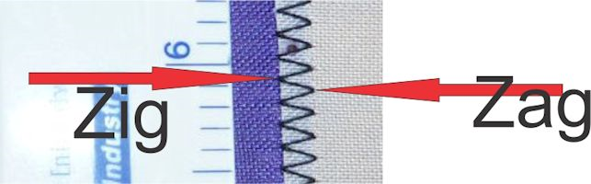
The aim will be for your stitch width to completely encase the overlapped seam width where colours join.
Above image shows white fabric overlapping blue fabric, with white facing you. You'll see the hint of blue below, and can use that to guide where you aim your needle on each zag. The zig stitch should then line up with the zig side.
**This is NOT like ripstop nylon applique.
**There will be no back-cutting.
**If your overlap is more than the allotted amount (3mm) then your 4mm stitch will not encase both hot-cut edges. Your fabric pieces will also NOT line up with the rest of your banner pattern.
2.TOOLS
Usual sewing box kit. Portable light table if you have one, but 2013 worked fine without.
Bulldog clips x 2 (lge) (or clothes pegs) for holding the rolled up banner cloth which you're NOT currently sewing, but don't want it to fall off your work table.
Black thread - I *suggest* a meaty / thick polyester which takes a size 12 or 14 needle - purely for the aesthetic look. A chunky black zigzag seam line presents a beautiful dark shadow in sunlight, which makes your design stand out much like a lead-light window does.
(We use "Rasant 75 cotton-wrapped polyester core" here, but purely for commercial reasons. There's no right or wrong thread, but no need to buy expensive for banners.
Dotting tool. We recommend a 40W iron with a ballpoint-type tip - below shows it measures approx 1mm diameter, and the example alongside shows white as dotted ready for sewing, with yellow & red already sewn.
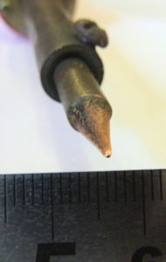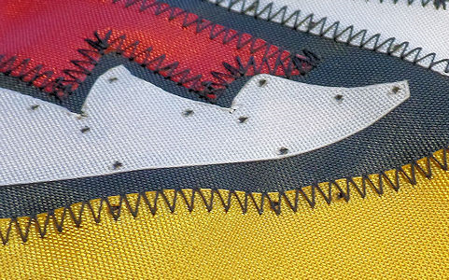
The 2 layers of fabric are hot-welded in place by a quick application of heat in the shape of the dot, using the opposite hand/finger to PRESS the weld together.
REPLY TO ALL - if you need more on this content.
Next email #2 will cover additional much-needed information and give you time to do some practice.
Enjoy the sunshine there.
Bigger. Brighter. TOUGHER .
Linda Sanders - Fabric Leadlight artist
w: www.ozfeathers.com.au
e: info@ozfeathers.com.au
f: https://facebook.com/ozfeathers
p: +61 8 8556 2681
postal: PO Box 758, Willunga SA 5172, Australia

